**Docker Commands**

**ps:** Prints a list of running containers

*Ex. sudo docker ps -a*

**images:** Displays all locally available images

*Ex. sudo docker images*

**build:** Creates a new image from a Dockerfile

*Ex. sudo docker build* **[pathName]**

**pull:** Import an image from a repository

*Ex. sudo docker pull ubuntu:18.04*

**create:** Creates a new writeable container

*Ex. sudo docker create -t -i* **[imageName]****[commandName]**

**run:** Creates a new container and executes a specified image

*Ex. sudo docker run --name* **[containerName]** *--rm -i -t ubuntu bash*

**exec:** Run commands in running containers

*Ex. sudo docker exec -d* **[containerName]** *touch /tmp/foo.txt*

**stop:** Kill specified running containers (when possible)

*Ex. sudo docker stop* **[containerName]**

**start:** Begin to run stopped containers

*Ex. sudo docker start* **[containerName]**

**rm:** Deletes containers

*Ex. sudo docker rm $(docker ps -a -q -f status=exited)*

**rmi:** Deletes images

*Ex. sudo docker rmi ubuntu*

**rename**: Rename docker images

*Ex.* *sudo docker rename [old name] [new name]*

**docker-compose up**

**docker-compose down**

**docker-compose kill**

**docker-compose restart**

**Networking:**

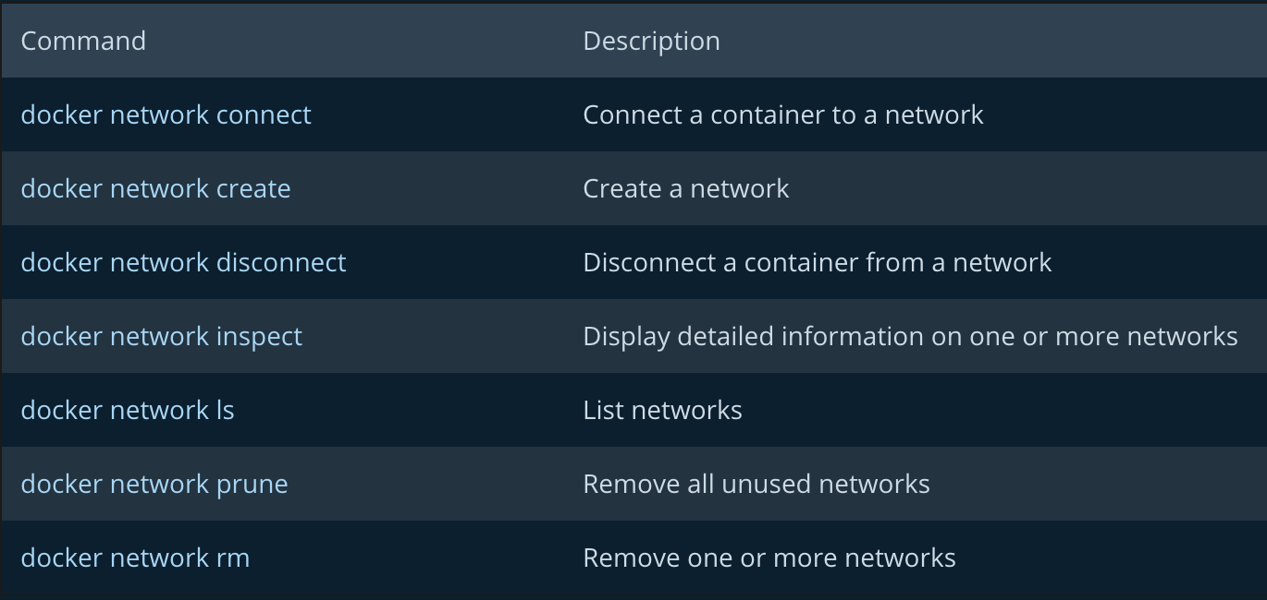

**Other commands**

* *sudo docker run -it --net=mmandulak1_default [img_id]*
  + Runs a container on network with img_id
* *sudo docker run -it --rm --name mmandulak1_LDAPtest -p 389:389 -d -e DEBUG_LEVEL=1 -e DOMAIN=linuxlab.salisbury.edu -e ORGANIZATION=”Salisbury University” -e PASSWORD=password -v mmandulak1 _ldap:/var/lib/ldap --net=mmandulak1_default mwaeckerlin/openldap*
* *ldapadd -x -H ldap://mmandulak1_openldap*

*-D cn=admin,dc=mycompany,dc=com -W [pswd]*

* + Add data element to LDAP server
  + -x: Simple binding
  + -H: (URI) simple binding for root account
* *ldapsearch -x -D cn=admin,dc=example,dc=org -W -b dc=example,dc=org -H ldap://openldap*

* *sudo docker run -v $PWD/root:/root -it --net=mmandulak1_COSC425 -p 50001:80 4250c2878*

**For pushing branch to repository**

git checkout <branch_name>

git pull

git add .

git commit -m “message”

git push

**Updates ubuntu packages**

apt-get update

**Install Node.js and node package manager**

curl -sL <https://deb.nodesource.com/setup_10.x>

sudo -E bash

sudo apt-get install -y nodejs

sudo apt-get install npm

**Install typescript**

npm install -g typescript

**Runs all config processes and TypeScript compilation**

npm run start